
SRM Institute of Science and Technology
SET B
College of Engineering and Technology
School of Computing
Department of Networking and Communications
Academic Year: 2022-23 (EVEN)
Test: CLA-T1 Date: 15-02-2023
Course Code & Title: 18CSC311J Web Design and Development Duration: 1 Hour
Year & Sem: III Year / VI Sem Max. Marks: 25

Course Articulation Matrix:
S.No. | Course Outcome | PO1 | PO2 | PO3 | PO4 | PO5 | PO6 | PO7 | PO8 | PO9 | PO10 | PO11 | PO12
1 | CO1 | 2 | - | 3 | - | - | - | - | - | 3 | - | - | -
2 | CO2 | 2 | - | 3 | 3 | - | - | - | - | 3 | - | - | -
3 | CO3 | 2 | - | 3 | - | 3 | -- | - | - | 3 | - | - | -
4 | CO4 | 2 | - | 3 | - | - | - | - | - | 3 | - | - | -
5 | CO5 | 2 | - | 3 | - | 3 | - | - | - | 3 | - | - | -

Part - A
(5 x 1 = 5 Marks)
Instructions: Answer all
Q. No | Question | Marks | BL | CO | PO | PI Code
1 | Which of the following specifies relationship between current document and external resource?  a) <meta>  b) <style>  c) <link>  d) <title>  Answer: (c) | 1 | L1 | 1 | 1 | 1.4.1
2 | Which tag specifies where in a text to add a line-break?  - <lb>  - <wbr>  - <mark>  - <br>  Answer: (b) | 1 | L1 | 1 | 1 | 1.4.1
3 | Select the correct statement from the following related to usage of CSS in web development.  - Device Compatibility  - Enhanced user experience  - Security Challenges  - Great accessibility  Answer: (c) | 1 | L2 | 1 | 1 | 1.4.1
4 | What will be the output of the following JavaScript code?  <p id="demo"></p>  <script>  var js = 10;  js *= 5;  document.getElementById("demo").innerHTML = js;  </script>  a) 10  b) 50  c) 5  d) Error  Answer: (b) | 1 | L2 | 1 | 2 | 2.4.1
5 | Which is the property that is triggered in response to JavaScript errors?  - onmessage  - onexception  - onerror  - onclick  Answer: (c) | 1 | L1 | 1 | 1 | 1.4.1
Part - B
(2 x 4 = 8 Marks)

6 | Describe any 5 HTML5 layout structure with example program.  Answer: Any 5 elements explanation.  - Section  - Header  - Footer  - Article  - Address  - Meter  - Details  - Summary  - Aside  - Figure  - Figcaption  - Nav  - wbr | 4 | L1 | 1 | 1 | 1.4.1
7 | Write a program using JavaScript DOM event handling which changes the color of a Text using mouseover and mouseout events.  Answer:  <html>  <body>  <p id="line1" onmouseover="showMore()" onmouseout="showLess()">  Mouse events</p>  <script>  function showMore(){  document.getElementById("line1").style.backgroundColor ="blue";  }  function showLess(){ document.getElementById("line1").style.backgroundColor ="red";  }  </script>  </body>  </html>  Output:  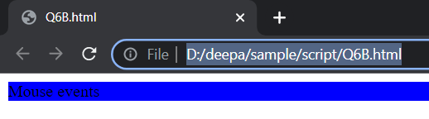 | 4 | L2 | 1 | 2 | 2.4.1
8 | Design a password validator that displays informative error message if any of the following occur:  - The passwords entered don't match  - the passwords are not at least 8 characters long  Answer:  <!DOCTYPE html>  <html>  <body>  <form name="myForm" onsubmit="validate()">  Password: <input type="password" name="pwd"/>  <input type="submit"/>  </form>  <script>  function validate(){  if(document.myForm.pwd.value.length < 8 ) {  alert( "Please provide minimum 8 characters." );  document.myForm.pwd.focus() ;  return false;  }  }  </script>  </body>  </html>  Output:  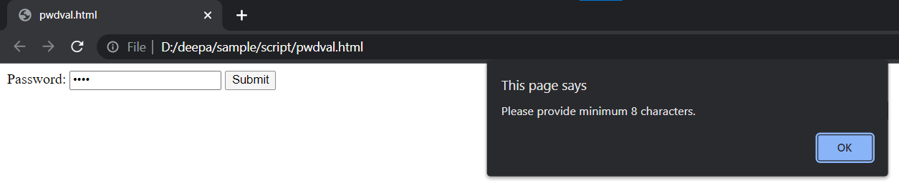 | 4 | L2 | 1 | 2 | 2.4.1
Part C
(1 x 12 = 12 marks
9 | Design a calculator using HTML5, CSS and JavaScript with the following features  - Addition, subtraction, multiplication, division, clear operations.  - Check for empty answer textbox. If user left the field empty, display alert message.  Solution: Scheme of evaluation  - Calculator design (HTML, CSS)- 6 marks  - Operations- 2 marks  - Empty checking - 2 marks  - Output – 2 marks  Program:  <!DOCTYPE html>  <html lang = "en">  <head>  <title> JavaScript Calculator </title>  <style>  #clear{  width: 270px;  border: 3px solid gray;  border-radius: 3px;  padding: 20px;  background-color: red;  }  .formstyle  {  width: 300px;  height: 530px;  margin: auto;  border: 3px solid skyblue;  border-radius: 5px;  padding: 20px;  }  input  {  width: 20px;  background-color: green;  color: white;  border: 3px solid gray;  border-radius: 5px;  padding: 26px;  margin: 5px;  font-size: 15px;  }  #calc{  width: 250px;  border: 5px solid black;  border-radius: 3px;  padding: 20px;  margin: auto;  }  </style>  </head>  <body>  <h1> Calculator Program in JavaScript </h1>  <div class= "formstyle">  <form name = "form1">  <input id = "calc" type ="text" name = "answer"> <br> <br>  <input type = "button" value = "1" onclick = "form1.answer.value += '1' ">  <input type = "button" value = "2" onclick = "form1.answer.value += '2' ">  <input type = "button" value = "3" onclick = "form1.answer.value += '3' ">  <input type = "button" value = "+" onclick = "form1.answer.value += '+' ">  <br> <br>  <input type = "button" value = "4" onclick = "form1.answer.value += '4' ">  <input type = "button" value = "5" onclick = "form1.answer.value += '5' ">  <input type = "button" value = "6" onclick = "form1.answer.value += '6' ">  <input type = "button" value = "-" onclick = "form1.answer.value += '-' ">  <br> <br>  <input type = "button" value = "7" onclick = "form1.answer.value += '7' ">  <input type = "button" value = "8" onclick = "form1.answer.value += '8' ">  <input type = "button" value = "9" onclick = "form1.answer.value += '9' ">  <input type = "button" value = "*" onclick = "form1.answer.value += '*' ">  <br> <br>  <input type = "button" value = "/" onclick = "form1.answer.value += '/' ">  <input type = "button" value = "0" onclick = "form1.answer.value += '0' ">  <input type = "button" value = "." onclick = "form1.answer.value += '.' ">  <!-- When we click on the '=' button, the onclick() shows the sum results on the calculator screen. -->  <input type = "button" value = "=" id="equal" '>  <script>  var e=document.getElementById("equal");  e.addEventListener("click",ehandler);  function ehandler()  {  if(document.form1.answer.value ==0)  alert("Enter value");  else  form1.answer.value = eval(document.form1.answer.value);}  </script>  <br>  <input type = "button" value = "Clear All" onclick = "form1.answer.value = ' ' " id= "clear" >  <br>  </form>  </div>  </body>  </html>  Output:  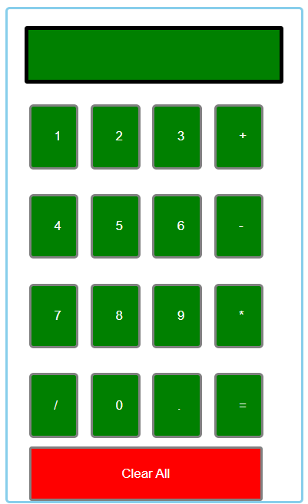 | 12 | L3 | 1 | 3 | 3.4.1
OR
10 | Explain the JavaScript user define objects and built-in objects with example program for each.  Answer:  Object is an real world entity having state and behaviour (properties and methods). JavaScript is object-based language. Everything is considered as object in JavaScript.  Types of Object:  - User-defined objects  - Built-in objects ( such as Date and Math objects)  - Browser objects (such as window, navigator, and history objects)  - Document objects (for example, link, forms and images)  User defined Object: 6 marks  - In JavaScript, there are three ways to create user-defined objects to manage enormous tasks and data sets within an application. They are:  - By object literal  - By creating an instance of Object directly (using new keyword)  - Using object constructor  I. Literal method: Using property values of an object  var person = {  firstName: "John",  lastName: "Herry",  age: 25,  skinColor: "White“  myfunction:function() {  document.write(student.firstname);  };  II. Using Object instance.  var myCar = new Object();  myCar.make = "Indian";  myCar.model = "HigherXLV";  myCar.color = "Red";  myCar.year = 2022;  mycar.myfunction:function() {  document.write(myCar.make);}  III. Using Object Constructor.  function employee(name, age, salary)  {  this.name = name;  this.age = age;  this.salary = salary;  }  var emp = new employee("Micheal", 26, 35000);  Built-in Objects: 6 marks  - Math Object  - String Object  - Array Object  - Date Object  - Document Object - DOM  - Window Object | 12 | L2 | 1 | 1 | 1.4.1

*Program Indicators are available separately for Computer Science and Engineering in AICTE examination reforms policy.

Question Paper Setter Approved by Audit Professor/ Course Coordinator

